**DAY 9 ASSIGNMENT SQL**

--1.Create AFTER UPDATE trigger to track product price changes

-- Create product_price_audit table with below columns:

--audit_id SERIAL PRIMARY KEY,

--product_id INT,

--product_name VARCHAR(40),

--old_price DECIMAL(10,2),

--new_price DECIMAL(10,2),

--change_date TIMESTAMP DEFAULT CURRENT_TIMESTAMP,

--user_name VARCHAR(50) DEFAULT CURRENT_USER

-- Create a trigger function with the below logic:

--INSERT INTO product_price_audit (product_id,product_name,old_price,new_price)

-- VALUES (OLD.product_id,OLD.product_name,OLD.unit_price,NEW.unit_price);

--Create a row level trigger for below event:

--AFTER UPDATE OF unit_price ON products

--Test the trigger by updating the product price by 10% to any one product_id.

– 1 We first create the table :

create table product_price_audit(

audit_id SERIAL PRIMARY KEY,

product_id INT,

product_name VARCHAR(40),

old_price DECIMAL(10,2),

new_price DECIMAL(10,2),

change_date TIMESTAMP DEFAULT CURRENT_TIMESTAMP,

user_name VARCHAR(50) DEFAULT CURRENT_USER)

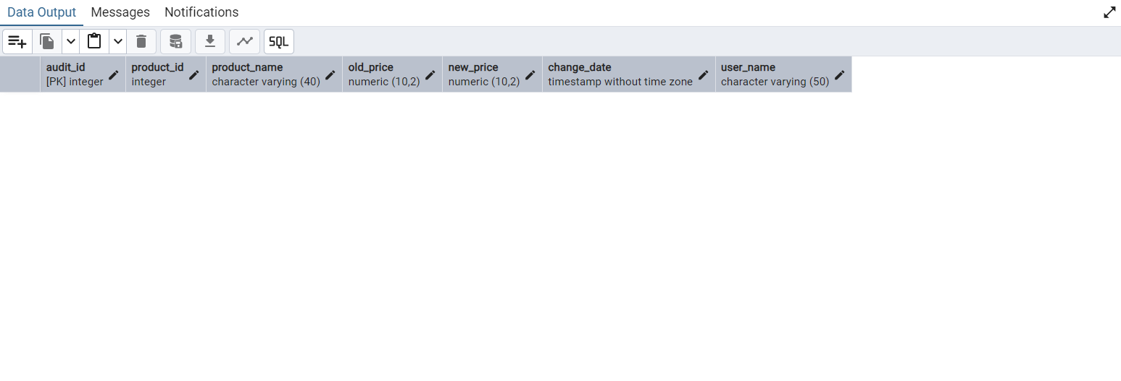

CREATE OR REPLACE FUNCTION log_new_price()

RETURNS TRIGGER AS $$

BEGIN

INSERT INTO product_price_audit (

product_id,

product_name,

old_price,

new_price

)

VALUES (

OLD.product_id,

OLD.product_name,

OLD.unit_price,

NEW.unit_price

);

RETURN NEW;

END;

$$ LANGUAGE plpgsql;

CREATE TRIGGER product_update

AFTER UPDATE OF unit_price ON products

FOR EACH ROW

WHEN (OLD.unit_price IS DISTINCT FROM NEW.unit_price)

EXECUTE FUNCTION log_new_price();

--test the TRIGGER

UPDATE products

SET unit_price = unit_price * 1.10

WHERE product_id = 10;

SELECT * FROM products

select * from product_price_audit

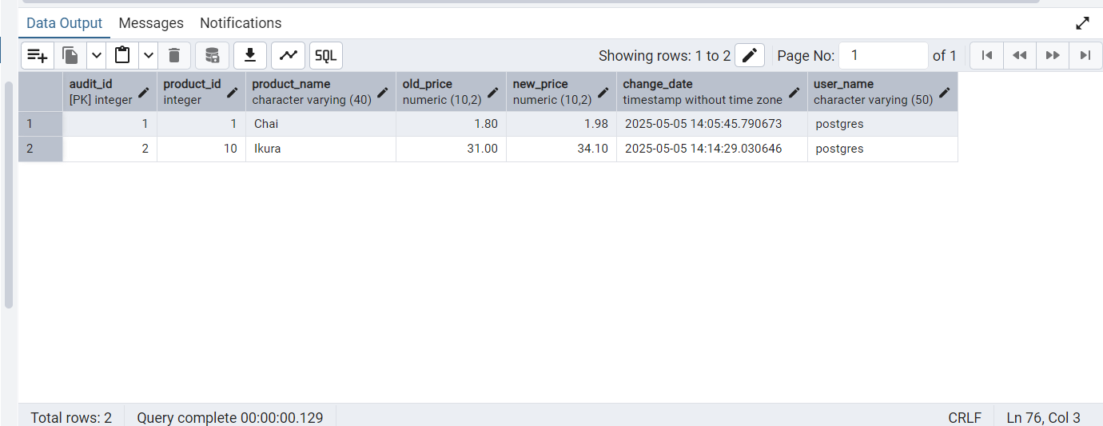

========================================================================

-- 2.Create stored procedure using IN and INOUT parameters to assign tasks to employees

-- Parameters:

--IN p_employee_id INT,

--IN p_task_name VARCHAR(50),

-- INOUT p_task_count INT DEFAULT 0

--Insert employee_id, task_name into employee_tasks

--Count total tasks for employee and put the total count into p_task_count .

--Raise NOTICE message:

--RAISE NOTICE 'Task "%" assigned to employee %. Total tasks: %',

--p_task_name, p_employee_id, p_task_count;

--After creating stored procedure test by calling it:

-- CALL assign_task(1, 'Review Reports');

CREATE TABLE IF NOT EXISTS employee_tasks(

task_id SERIAL PRIMARY KEY,

employee_id INT,

task_name VARCHAR(50),

assigned_date DATE DEFAULT CURRENT_DATE

)

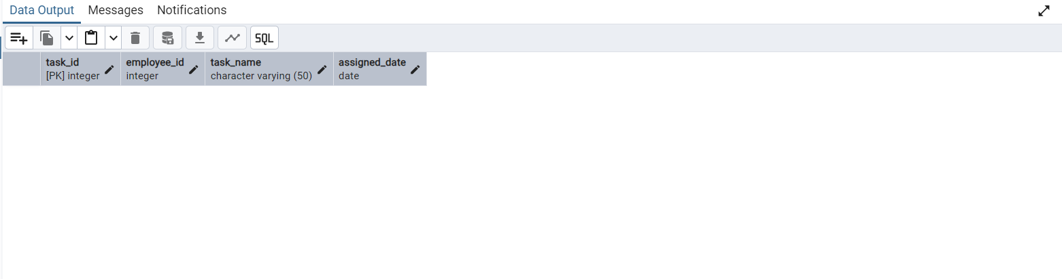

INSERT INTO employee_tasks(employee_id,task_name)

VALUES(1,'Insert Data'),

(2,'Update Data'),

(3,'Delete Data')

SELECT * FROM employee_tasks

CREATE OR REPLACE procedure assign_employeetask_value(

IN p_employee_id INT,

IN p_task_name VARCHAR(50),

INOUT p_task_count INT DEFAULT 0

)

LANGUAGE plpgsql

AS $$

BEGIN

IF NOT EXISTS (SELECT 1 FROM employee_tasks WHERE employee_id=p_employee_id ) THEN

RAISE EXCEPTION 'Employee_id % doesnot exist',p_employee_id;

END IF;

INSERT INTO employee_tasks(employee_id,task_name)

VALUES (p_employee_id,p_task_name);

SELECT COUNT(task_id)INTO p_task_count

FROM employee_tasks

WHERE employee_id=p_employee_id;

RAISE NOTICE 'Task "%" assigned to employee %. Total tasks: %',

p_task_name, p_employee_id, p_task_count;

END;

$$;

CALL assign_employeetask_value(1,'delete Reports');

**Stored procedure created:**

